Prim’s vs Kruskal’s
This is the third project in my study on the 4 main software development methodologies, where I attempt to understand how they are applied in practice to the process of developing a solution. I will also use these projects to improve my planning skills and understand the mistakes I make whilst making my own personal projects. The last project that I made was a unity project where a ball could be thrown and interact with a room, despite the fact that the project was never completed, I learnt a lot from the experience.
This time, my goal is to make a project that illustrates the difference between Prim’s and Kruskal’s MST algorithm in real time. As part of the project, you will be able to place down nodes, connect them and then use the MST algorithms to see how they change the graph in different ways. The reason I’m doing this is because of my computing NEA, where I am creating a dungeon generator that uses Kruskal’s Algorithm. I would be very interested on seeing how different the resulting tree could look with either algorithm.
Originally, I was planning on doing this in HTML and JavaScript – a language that I am not greatly experienced in. yet across the last two projects, I have written 20,000 words and still not be able to finish either project to the degree that I planned. Due to this, I will be programming the project in python to ensure it is completed, I will however code my final project as a website to push myself.
My first project was programmed with Spiral, and my second was programmed with waterfall. This leaves Rapid application development and Agile left for me to choose between. I will firstly display the advantages of each…
Rapid Application Development (RAD)
- extremely flexible
- focuses on usability
- requires constant communication with client (or evaluation in this case)
- not suited to larger projects
Agile
- extremely flexible
- focuses on code quality and efficiency
- difficult to control
- communication issues within larger teams (not an issue for me)
To me, the choice that makes the most sense is Agile. Not only because it suits this project, but because Agile would not be very suited to my next project. Agile will push me to write higher quality and more efficient code in python (a language I am very confident in), meaning that I will learn much more from the project. Additionally, focusing on code quality in a language that I am learning through the project would not be beneficial in the slightest, therefore it makes no sense to leave this methodology for my next project.
(I would also like to note that Agile is actually a group of methodologies, yet for simplicity I am treating it as only one that encapsulates the overall features of an agile methodology.)
So, what will agile change in this project? Well, there are a few main features that will make this project greatly different from any that I have programmed thus far.
- Programming is done in “sprints”, each sprint will include a useful practical feature that is worked on. After each sprint, it is discussed as to what went well and what went wrong. Additionally, analysis and research will be handled individually for each sprint. The sprints will be decided at the start of a project.
- Less focus on documentation, Agile focuses much more on programming over planning. Typically, a small amount of time is spent on planning the project and the rest is focused on the programming of it.
- Focus on code quality. This is seen much more in extreme programming in comparison to agile, however I believe still deserves some focus. Many of the practices used for code quality rely on working in a team, however there are still many practices that I can implement. This includes testing of the solution after each sprint and limiting the time that I program each day.
With this understanding, I could now move onto planning the sprints.

Sprint planning
Before I decide on the sprints, it is important that I lay out all of the necessary features and my time constraints.
Features:
- place down a node
- connect nodes together (whilst calculating distance between nodes)
- running Kruskals on a collection of nodes
- running Prim’s starting from a node
This is currently being written as of the 11th of July, the project must be completed by the end of the month. This means that after today, I will have 20 days to complete the project. Considering the fact that I will likely need an additional day for evaluation of the process, that gives me 19 days of programming to spread between these features.
With this in mind, these are the sprints that I will be using…
- 4 days (finished before July 16th) – place down a node. This process should be quite simple of just placing an image on the screen at a position and storing information about it, therefore it has been given the least amount of time.
- 5 days (finished before July 21st ) – connect nodes together. Initially, this does not seem like it would be that challenging, however I am much more concerned with how I store information about connections, as this will be used throughout the entirety of the program from this point on and must be efficient.
- 5 days (finished before July 26th) – running Kruskal’s on a collection of nodes. I am frankly not too concerned with the programming of Kruskal’s, as I have already done a large amount of research into it in my NEA for computer science. Despite that, this will be challenging and will need to be tested thoroughly.
- 5 days (finished before July 31st) – running Prim’s starting from a node. This is the sprint that I am most concerned for, I have not programmed Prim’s before and am unsure how to. However, It should be much simpler to code than Kruskal’s judging from what I know about it.
Without further ado, it is already time to begin our first sprint.

Sprint 1
research
To begin the sprint, I will research ways to create node like objects in a python window. This will most likely be through TKinter or CustomTkinter as I have the most experience with these packages.
I found that I could use the TKinter canvas to create circles very easily, the issue came with resizing them as the window changes – as they have no relX or relY parameters. The solution to this would be using this line of code below.
canvas.bind("<Configure>", drawNode)
this would redraw the node every time the canvas is configured by the screen size changing. I did however still have a few concerns.
firstly, I want the ability to place down nodes by clicking on the screen, this would need some sort of library and tracking of the mouse position. Additionally, I will likely need to pass information into the drawNode method and am unsure of how I would accomplish that.
The first issue was a simple case of finding the lines of code to get that information, where I ended up using the mouse library.
mouse.on_click(placeNode) – sets a function to run when the mouse is clicked
mouse.wait() – keeps the program running whilst waiting for the click
mouse.get_positiion() – returns the current position of the mouse
The second issue was more of a design consideration if anything, although I am sure there are some interesting ways of passing information into the function, I would much rather just use a global list of all current nodes, I would then be able to make each node an object that can be tracked easily.
Due to this cycle’s simplicity, that is all that was necessary for research.

design
This design will be kept short and sweet as a list of everything that will be added in this cycle.
- Tkinter window created
- Mouse tracking of position and clicks
- Ability to place down a node (circle) on click at a certain position.
- Nodes are resized to fit the screen size and when placed this is considered.
- Nodes are a class, object instances are created for each new node and stored in a global list
I believe all of this should be quite easy to implement, the only section that I could imagine giving me some issues is the resizing of the nodes – as there are many ways of implementing it. The way that I plan to do so, is to keep everything in the same shape but just make it much smaller as the window changes size. This means that circles will stay as circles instead of being squished into an oval shape if the window is changed on only one axis.
Now, despite the small amount of planning required for this cycle, it is time to move into implementation

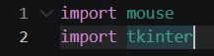
Implementation
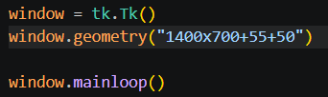
the first step was to import the necessary packages, this included making a virtual environment to store the mouse package inside of.
I could then continue on to making the window with arbitrary geometry that I decided looked nice – as it covered most of the screen whilst leaving space.
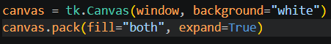
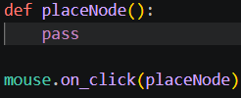
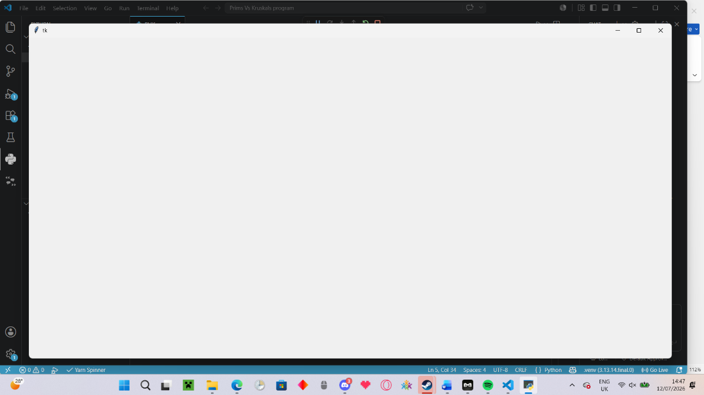
i could then set up the canvas and move on to the basics of the node placement.

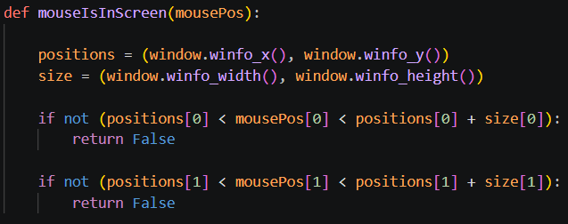
I now felt as if the program was prepared for me to start doing the much more complicated coding in. The first step towards placing the node was checking the validity of the mouse position, I decided that this would be easiest to achieve by creating a separate function that returns a Boolean of whether the mouse is inside the screen or not.

This was the end result of the function, getting the window size and position from the winfo and checking if the mouse is contained within the bounds of the screen. If it is not, then the function returns false.
The next step would be to place down the node at that position, yet I already know that if I try to place the shape on the canvas at the position directly, then it will not scale correctly with the screen as it changes size.
This is where node storage comes into play, I can store information about each node so that when the canvas changes size, the nodes change position / size accordingly.
I firstly, just wanted to place a node down alone first at the mouse position before focusing on rescaling. I opted to create a radius variable for the circular node, allowing me to easily change the size of any node in the future.
This already came with issues in rescaling however, as this would lead to nodes of different sizes when the screen size changes and another node is placed. This meant that I would have to store the radius as a relative size and calculate the pixel height and width when it is placed. Without enough information on how scaling would work just yet, I decided to leave this for later in the sprint.
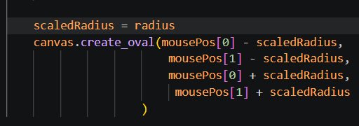
After briefly fixing an issue with the mouseInScreen() method where I never return true. I created the logic to place an oval at a certain position.

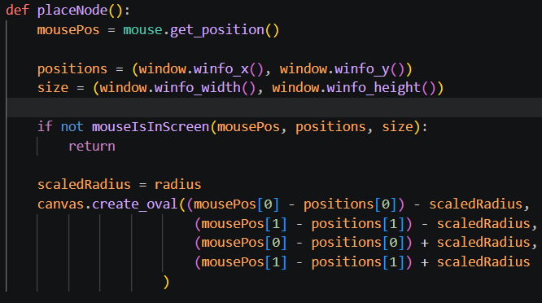
This did work; however, nodes were not being placed at their centre. I realised that by changing the screen position the node placement around the mouse would change, this lead me to the realisation that I was placing nodes on a screen position instead of a window position. I subtracted the window geometry to ensure the code worked.
Additionally, due to the fact that I required the position of the screen, I decided to calculate the window position and size inside the placeNode() method and pass them into the mouseInScreen() method.
I would also like to leave as a side note that this code for some reason did not create an oval centred on the button, it was still somewhat off by a small margin but enough to be satisfactory.
The next step was to calculate the relative position of the node on screen and store them so that they can be replaced as the canvas changes shape.
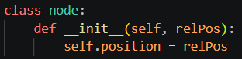
this led to the code seen here. Where I create a new instance of the node class that stores the relative position of the node on the screen.
Now with this information stored, I could actually begin the rescaling of the screen. This would have to be implemented in a very specific way to ensure that the aspect ratio of the screen is kept correct. The size of the initial window is 1400x700, this means that the window will scale at a 2:1 ratio. To make this easier for myself, I will write down the geometry of the new bounding box position of the screen to use in my calculations.
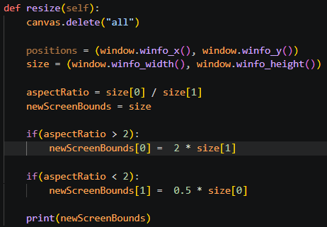
Here was my first attempt. It may not make much sense to somebody who is not coding it, but it will make sense soon. Already there was an issue in this code, I was attempting to change the values of the newScreenBounds variable when it is immutable. I simply replaced the entire tuple instead.
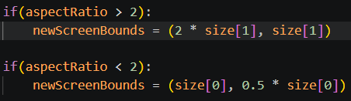
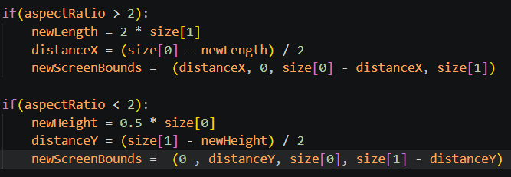
And this gave me values I liked a lot more. However, I had still not calculated the position of the new screen, I decided to change the entire tuple to be more alike to a bounding box by storing the upper left and lower right corner positions.

To be absolutely certain that my calculations are correct I decided to draw a box with the calculated bounds and see if they correctly drew the rectangle.

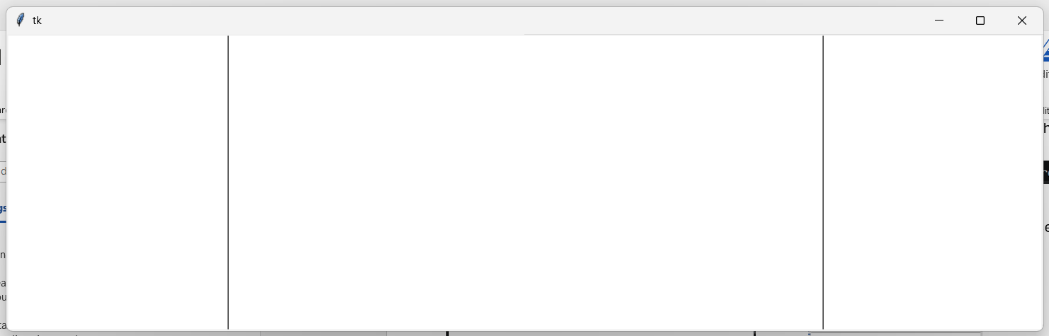
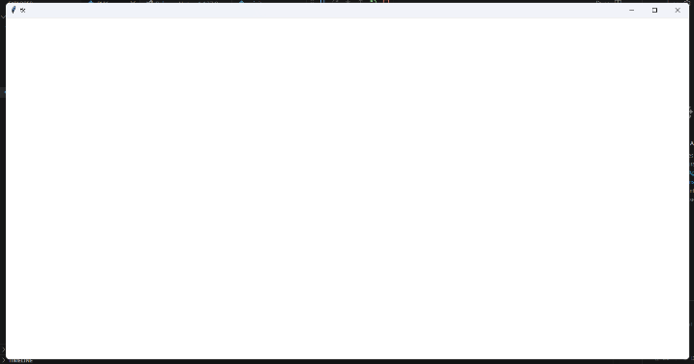
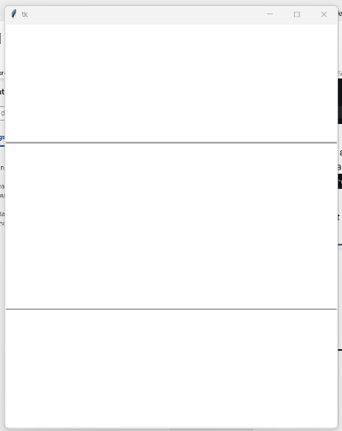
And it worked exactly as I was hoping! Below reveals how the bounds look in practice
The newScreenBounds will represent the biggest rectangle of an aspect ratio 2:1 that can be made in the current screen.
The next step is to place all nodes onto this screen.
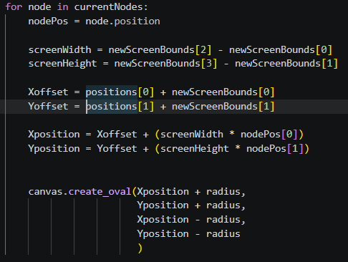
This was my first attempt at placing the nodes on the screen. This method will calculate the width and height of the rectangle and the offset of the rectangle on the screen. The position will then be calculated with this by getting the relative position in the area of the rectangle and then adding on the offset.
This however did not work, I found it worked alright when changing the size of the window from the right but it didn’t work when changing the size from the left, instead going much faster than it should have. I assumed this had to be some issue with the offset because by changing the left side of the window, Im also changing its position. Through this, I realised that I was using the screen position of the rectangle instead of the window position. This led me to change the offset to work correctly.
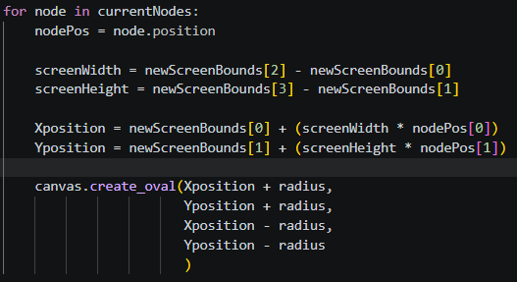
The only part that was left for me to do was scale the radius accordingly. This would be simple; I would divide either the window height by 700 or the window width by 1400 and then multiply that by the radius. This would mean that the initial radius will specify the radius when the screen is 1400x700 and this will then scale from that point on.
As I will also need this radius when placing nodes, I decided to turn the entire process of calculating the scaled radius and bounding box into a function to reduce redundant code.
Whilst doing this I also realised that the positions variable was not needed and removed the line for calculating it.
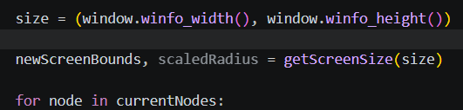
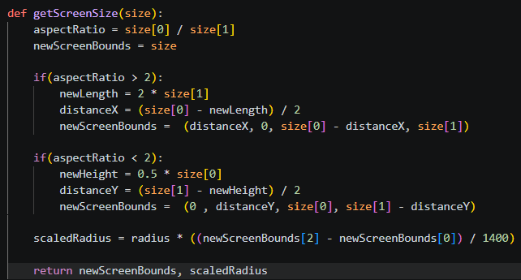
I then implemented the scaledRadius instead of the base radius and it worked perfectly!
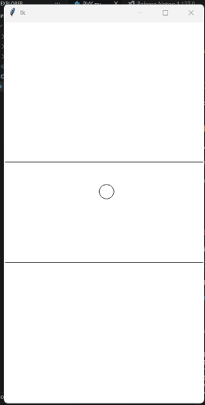
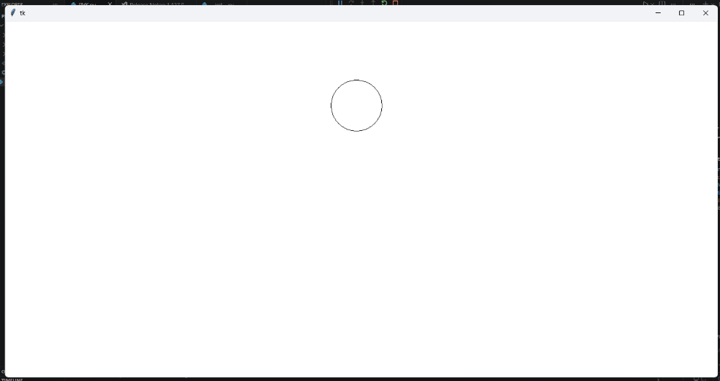

--------->

Now with the basic functionality working, I would need to fix a few issues that I had seen throughout development. These errors are:
- An error occurring when the aspect ratio is already 2:1
- The scaled radius being applied on initial placement
- Being able to click on the screen and place nodes when there are other tabs over it
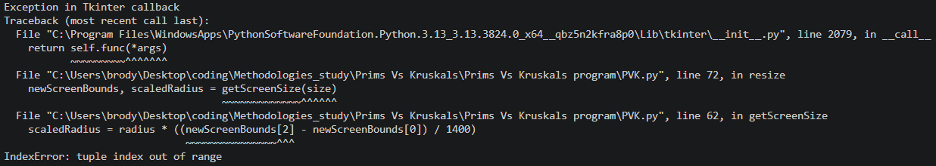
This is the first error.

This actually made a lot of sense; the bounding box is firstly set to the size variable before the if statements take place. If none of those statements end up running, then the bounds would store the wrong number of values and wrong values. To fix this I changed the base value from being size to being the bounding box of the window itself – as that is already correct.
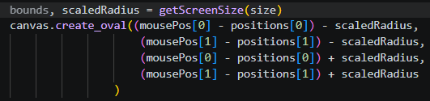
The issue of the scaled radius on placement was also an easy fix of just using the function to calculate it

The final issue was the one that I was most concerned of. I would need to find some way of finding out what the top window is at any given point, I was not sure of how to do this and decided to take some research.
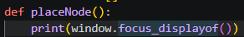
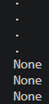
I firstly found this line of code: window.focus_displayof() that outputs the top window. I attempted to use this to check if the tkinter window is the top window. Just by playing around with the function, I found that it would output “.” Only if the tkinter window was the one that was clicked on.
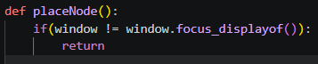
This would most definitely work because “.” Is also what’s outputted when I print the window itself. I would simply make a guard clause to return from placing the node if the TKinter window is not the top one.

With that working, I now had concluded in making everything for the first sprint. I commented my code for readability and then moved on to testing.

Testing
My testing would include me going through every major feature that was added in this sprint and ensuring it is working exactly as planned.
TKinter window created
Upon opening the program, I could notice that the window opens immediately with a white background and the name “Tk” where its size can be changed and moved around. I decided to change the name of the window to “MST demonstration” but that was it for this feature.

Mouse tracking of positions and clicks
This is another quite simple feature. The place node method will run when a click takes place, and it will use the current mouse position to place nodes. The only place where this may be incorrect will be the placement of nodes, where the circle is placed slightly below the mouse position, yet that fits more into the node placement feature. I will consider this feature completed for now.

Ability to place down a node (circle) on click at a certain position.
A node will be placed upon clicking, yet slightly below the position of the mouse, this becomes more noticeable at lower window sizes. I desperately wanted to find the cause of this issue and thus started experimenting with the node placement.
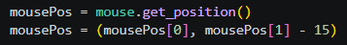
I firstly started by just adding a constant bias to the mouse position that would place it slightly higher.
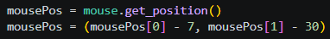
Already, this nearly fixed the problem, making it much harder to notice, yet it still was not completely centred. I also began to notice that the node was slightly offset to the right as well for some reason, I played around with values for a short while and settled on this code below.

Which, although simple, completely solved the problem. I can’t say I’m entirely sure of why this situation occurred, but it was fixed and that’s that.

Nodes are resized to fit the screen size and when placed this is considered.
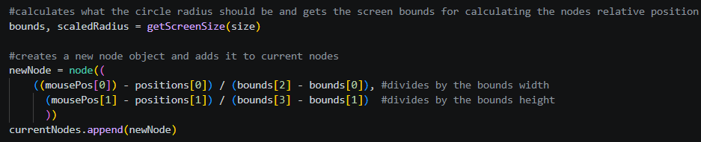
This all happens correctly par a section of the resizing. Upon placing a node at a lower window size than 1400x700, it will snap into a completely different position when resizing. I was fairly sure I knew why this was happening, I was using the position of the window to get the relative position of the node instead of the bounding box. I quickly changed the code to work with the bounding box instead.

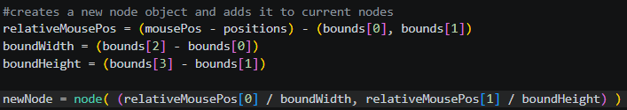
But then came the issue that the mouse position was not relative to the bounds. I would have to reprogram this section to all work in terms of the bound positions.

This was my first attempt, it most certainly looked a lot nicer, yet it was not possible to subtract a tuple from a tuple and so I received an error. I changed the code to work without tuple subtraction.
I also decided to clamp the relative position in between 1 and 0 so that all nodes would have to be within the screen bounds
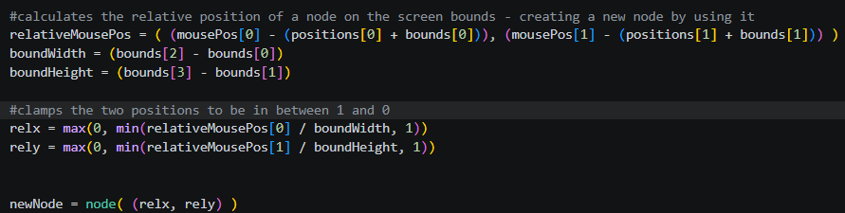
This code worked perfectly. The one issue that I had with it was that the position would only clamp once scaling had taken place. I thought It would take far too long to implement anything where I might make it work on placement, that’s when I realised I could simply replace the code to place the circle with the resize() method, as that will place the circle correctly anyway.
This worked as expected, I simply had to change the relative position to be clamped in between 0.05 and 0.95 so that nodes wouldn’t be placed directly on the screen border.
Now, I had perfect scaling and placement that I was quite happy with.

Nodes are a class, object instances are created for each new node and stored in a global list
This is completely true; the only way this would not be perfectly completed is that I have not stored all the information necessary inside the node class. Yet that will have to be considered in the next sprint when I am deciding what would be necessary.

Sprint 2
This sprint will be focused on connecting nodes with edges. Yet before I begin on implementing that I have a slight new road bump in development. Today is the 16/07 as it should be to abide to my timings, however from the 18th-21st I will be camping and at the end of august I will be on holiday, so the project cannot be pushed back further. This means that I will only have 4 days for each of the sprints from this point on, far from ideal yet I will have to make do.

Research
The main part of this sprint that I believe needs research is a method to create a line between two points on the screen. I am fairly sure that the rest I can figure out with knowledge I have gathered thus far, yet I will need some method to create a line between two points that is not placed over my nodes. The best solution to this problem in my opinion would be to:
- Find a way to draw a line between two points
- Find a way to place the line below the nodes.
The first was actually quite simple, I could use the canvas.create_line() method to create a line between two points with a specified width.
The method to change the sorting order for objects was also fairly simple. I would place a tag on all objects that I want to be above other objects and then raise that layer with the canvas.raise_tag(“”) method.
This actually turned out to be much simpler than expected, I could now move on to design.

Design
- Ability to select one node by right clicking on it. right clicking again on empty space will deselect it
- Selected nodes will change colour to indicate they are selected
- If a second node is selected after one is clicked, they are connected by a line
- Lines are placed below nodes in terms of sorting layers.
- Lines are scaled alongside nodes
- Any connected nodes have the two nodes and the distance placed in a sub array of a 2D array
Frankly, looking at the design in the current moment, this does not seem like it will be as big of an undertaking as the previous cycle as I will not have to program scaling from scratch. This seems very possible to have completed within 3 days.

Implementation
I decided that the best first step to begin with was the right clicking on nodes to select them. This could be broken down into a few major stages.
- Detecting a right click
- Checking the distance from all nodes to see which node it was (or if it was none)
- Changing the colour of the node and setting it to a variable called “selected”
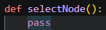
I decided to of course start from the beginning in detecting the right click. I looked through the functions inside the mouse package and noticed on_right_click(), using it the exact same way that I used on_click() just with a different method linked.

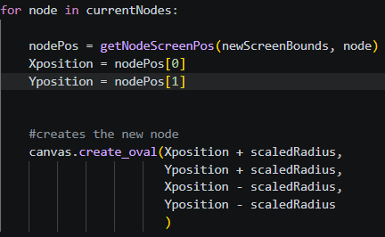
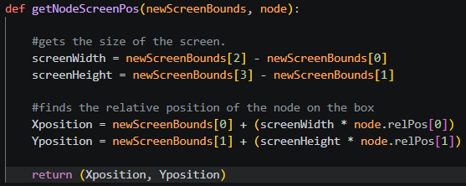
I then implemented the distance check. This would be as simple as getting the screen position of every node and checking the distance. It did make me think however, it would probably be incredibly inefficient to calculate the node position twice in the program. I decided to make it a separate function instead.

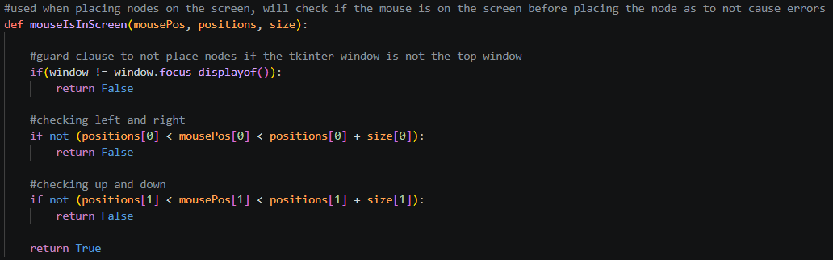
This did give me an error that the node class did not have the relPos attribute, it was instead the position attribute. Yet with that fixed the code worked as it did before. I also noticed that the beginning of the function to select a node would be the exact same as the beginning of the function to place a node, as it was simply handling the mouse position. I decided against creating a new function however, as the beginning of the method to place a node was mostly guard clauses and variable initialisation. I did decide to change the mouseIsInScreen() method though, also giving it the guard clause to check if the window clicked on is the top window.

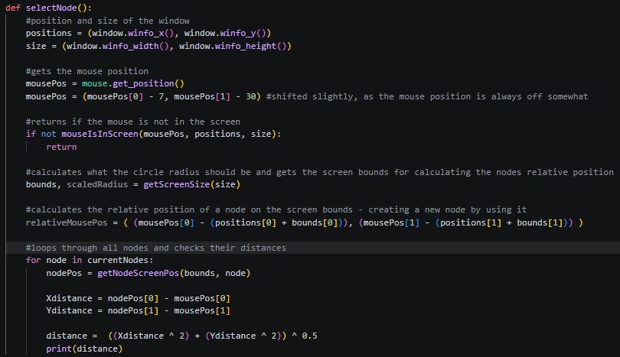
I was not particularly happy with how I had laid out the select node method and yet saw no way around assigning all of the variables. This was the current state of the method, which I could use to check if the distance calculations were correct.

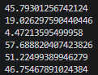
There were however two glaring issues that became immediately obvious. Firstly I was using the wrong operator for putting one number to the power of another, I should be using ** instead of ^. I was also using the mousePos instead of the relativeMousPos that considered the bounds.
By making these changes and clicking with on a single node on the screen, the output looked like this.
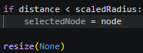
Which was perfect. I could now compare the node to the scaledRadius to select it.
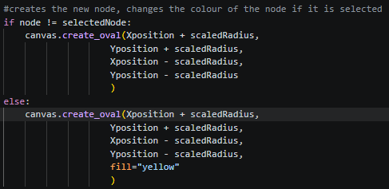
This is then how the final code looked like for the select node function. You may be wondering why I added a call to the resize method at the end, this is because it will likely be inside the resize method that I change the colour of the node, as this will mean the node will consistently change that colour even when resized.
Yet this was not changing the colour of the node. I first checked the value of the selectedNode variable right before the condition and found it was still None, this made me look back at the code to select a node, I realised that the selectedNode variable was greyed out, indicating it was used nowhere else. Realising that I was not using the global selectedNode variable, I quickly made the change and was able to select a node to turn it yellow.
The issue came in selecting a second node, it would simply just not work occasionally and work other times, the issue became more noticeable the more nodes that were placed down. I decided to check the distance to see if there were any anomalies. I found that the distance would give strange values when not in full screen but everything would work exactly as expected when in full screen.
This made me realize that I was working with a screen position for the node and a bound position for the mouse. I changed the mouse to work with a screen position instead and everything worked as intended.
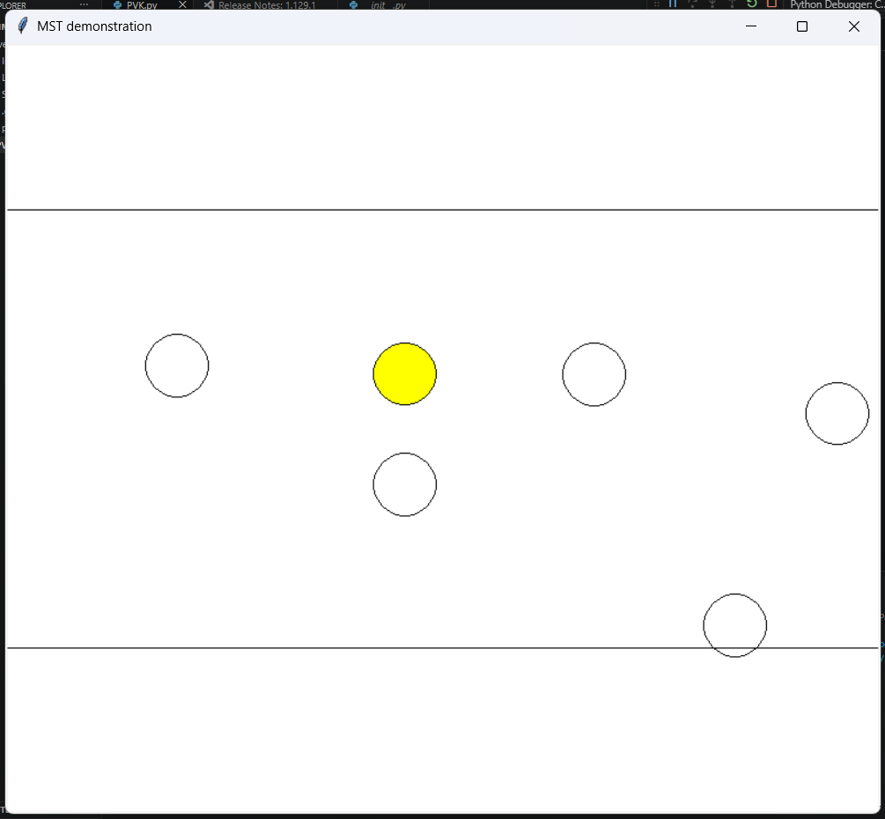
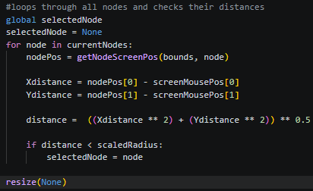
I could then quickly implement the logic to deselect a node by setting the variable of the selectedNode variable to None before the loop that sets the variable to a node if clicked on. Whilst doing this, I also found a fatal flaw in the code, I was resizing the nodes every single loop, which was heavily inefficient and would have a quadratic time complexity of 400 nodes resized with only 20 nodes. I fixed that also.
The next step would be to connect two nodes together via a line. Before I could begin on this though, I really wanted to decide on how I would be storing the connections between lines. The two ways that I could see of doing this was to store each node that one node is connected to inside the node class, the other would be a 2D array of every connection. The second option seemed more efficient, as I could then include the distance of the connection as part of each sub array. This did make me question however, would the node class ever get a second variable? If not, it would be redundant.
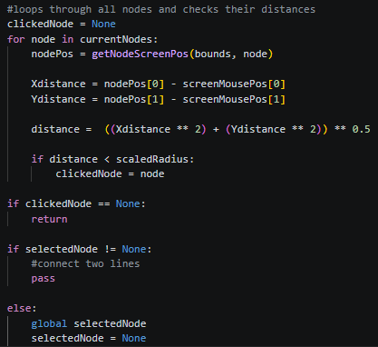
I started work on the logic for detecting when a second node is clicked after one is selected. As I would need the node that was clicked on, I did however have to change the code again somewhat to account for this by running my logic after the loop, storing the node that is clicked on and then checking if selectedNode is None or not.
This did have the issue that I use an if statement for the selectedNode before the “global selectedNode” line which caused an error, yet by fixing that, the code still did not work.
I realised quickly that I had mixed up my code, I had never set the selectedNode variable to the clickedNode variable, I also did not reset the selectedNode variable and resize if no node is clicked on. I changed my code to account for this.
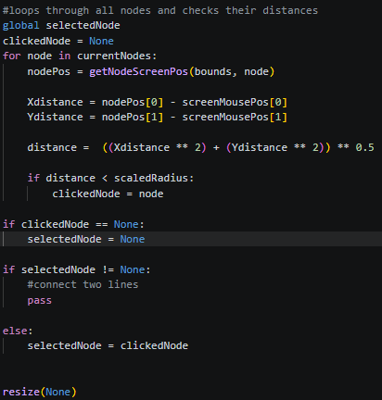
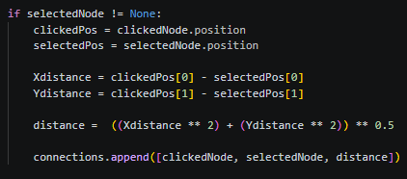
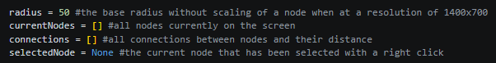
This code worked as expected, granted that nothing would happen if I clicked a second node with one already clicked on. I added a 2D array called connections and added the process to fill this array with the two nodes and the distance between to begin the process of creating the connections.
I used a similar approach to calculating the distance as I used earlier to calculate the distance from the mouse. I could then use this information to create a line between the two nodes. It did raise some questions about the most efficient method though, I could either look through the list of connections and create the line for the node when I already have it’s position. The other option would be to go through the connections list separately. I decided on the second option as it is simpler, if I begin to see massive performance concerns, then I will look into other methods.
Below is my first attempt, however it did not really go as I had planned…

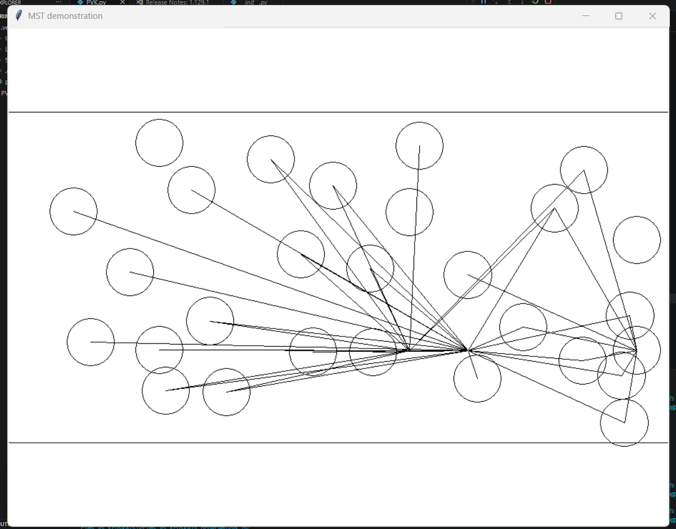
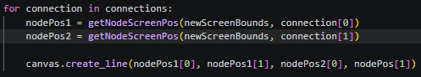

as you can quite obviously see, the nodes were not being connected in the way that they should have been. I was quite confused as to how this could have happened until I took a closer look at the code and realised that I was using nodePos instead of nodePos2 as the final parameter to the create_line() method.

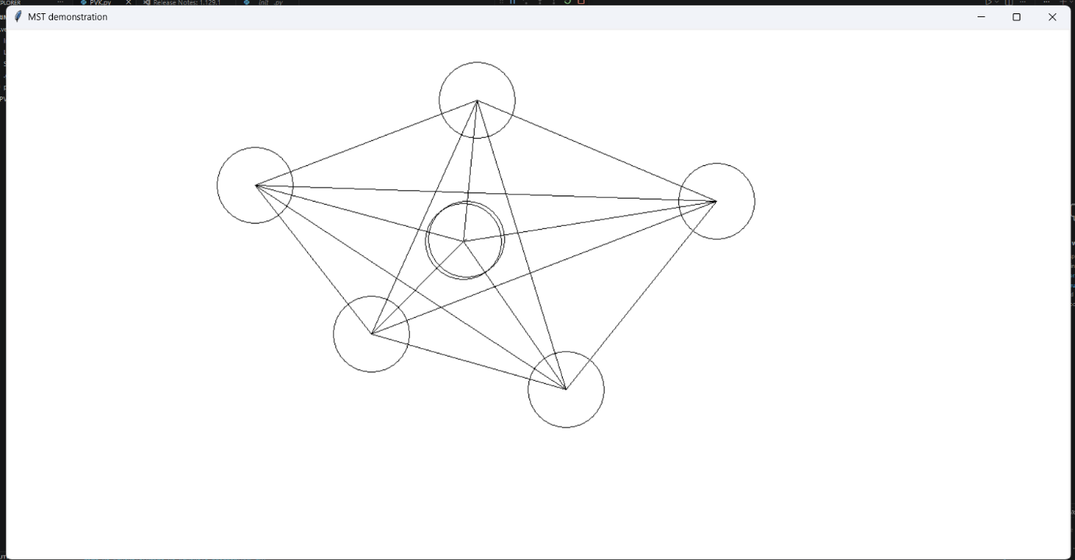
And to my surprise, already the code had worked, allowing me to connect nodes together to create fully fledged graphs, that’s not to say that there were no errors, I was aware of the fact that multiple connections could be made between two nodes infinitely many times, yet that was a problem I would solve in testing. The only things that I wanted to change as of yet was setting the selectedNode to None after connecting two lines and making the circles place on top of the lines.
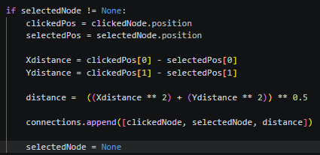
The first solution was extremely easy to fix and included adding a single line of code.

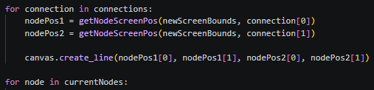
The second did have me thinking though. Originally, I was planning to use some code to layer the nodes on top of the lines to make the lines invisible. Yet, because of the fact that I was constantly running the resize function, I could just fill the nodes with a white colour and then draw the lines first so that the nodes are drawn on top.
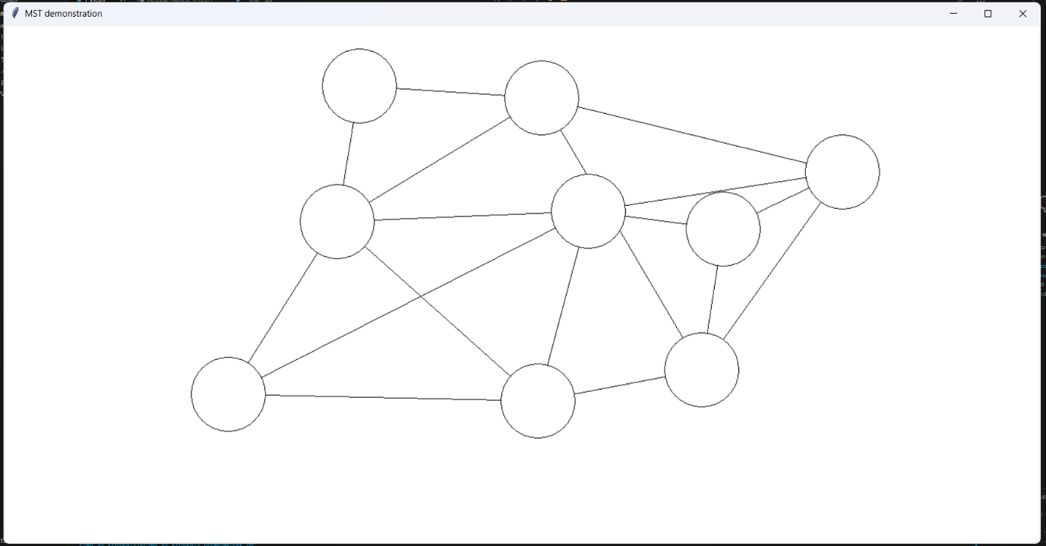
And this yet again surprisingly worked really effectively. I could now create graphs easily that looked extremely good. It should also be noted that all of the lines would scale alongside the nodes due to their implementation inside of the resize method. I could now move onto the testing of this sprint.

Testing
Ability to select one node by right clicking on it. right clicking again on empty space will deselect it
This worked exactly as I expected, nodes would be coloured yellow when selected and clicking on empty space or another node will deselect it. There could be some concerns with the efficiency of this process as right clicking (and left clicking) will cause the screen to stutter for a moment yet given my time constraints I decided this would not be a large enough issue to pour time into fixing.

Selected nodes will change colour to indicate they are selected
As stated before, nodes would be coloured yellow when selected and white when not. I could not find any errors that would change this at all.

If a second node is selected after one is clicked, they are connected by a line
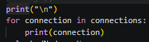
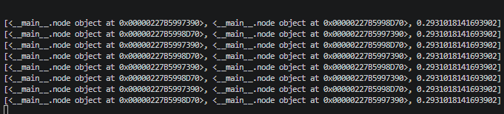
This does work and works with resizing yet I was concerned about being able to connect two nodes multiple times. Upon checking the connections array, I could see that this was a large issue.

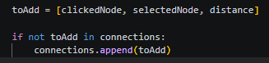
I simply added a check to see if the sub array was already inside of the 2D array before adding it to fix this.
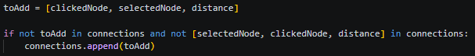
This mostly fixed the problem, yet connections could still be made the other way from the second node to the first. I changed the condition to account for this

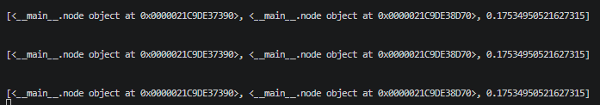
And this worked as it should! Keeping only one connection in the array if I repeatedly attempt to connect two nodes together, I removed the print statement and moved on.

Lines are placed below nodes in terms of sorting layers.
This problem was fixed in implementation, by placing the lines first, the nodes will always be placed on top. No matter how many connections or nodes I created I could not break this. It was only possible to see the lines under the nodes in the small flash when right clicking – yet I already stated I was not fixing that problem.

Lines are scaled alongside nodes
Due to my implementation inside of the resize method, this worked exactly as it should have, scaling in the same vein as the nodes do. There wasn’t even any lag when resizing the window which was quite fortunate. I found that I could change the window size as much as I wanted and the lines would follow perfectly.

Any connected nodes have the two nodes and the distance placed in a sub array of a 2D array
As you can see in the output of the connections array earlier, this does work. It did also make me notice that I was calculating distance in terms of relative distance across the screen. This should not be an issue as Primms and Kruskals both just need to know which distance is the lowest at any given point.
After finishing this sprint a whole day early, I commented my code and moved on to the next sprint.

Sprint 3
This sprint will be focused on presenting the process of Kruskal’s MST on the nodes in the window. In terms of time, I have finished this sprint with 9 days left for the remaining two sprints, this gives me a small amount of leeway to ensure that the project is completed in time. I am not too worried about this sprint just yet, as I have already done research into Kruskal’s implementation in the past and the connections are laid out in such a way that they are perfect for Kruskal’s.

Research
The Kruskal’s algorithm itself will include a lot of complicated usage of basic code. This means that I will likely not have to research much code for it to work, I will however have to research the algorithm itself to ensure that there are no misconceptions as I am programming. I would also like to make sure that the algorithm allows the user to interact and demonstrates how it works extremely effectively, this may require some research into how I will allow user input into the algorithm.
Firstly the algorithm itself. Kruskal follows a very simple set of steps.
- Sort the list of all connections in ascending order
- Go through the list and add each connection one at a time
- If a connection would form a cycle, don’t add it and move on to the next.
This is the most basic understanding that we learn in further maths, yet this will not work for implementation as it is difficult to check for cycles. That is where the union find algorithm comes in, which has its own set of steps.
- Initialise each node in the graph as its own “group”
- When a connection is added, union (merge) the groups of the two nodes into one if they are different groups
- If the groups are the same, don’t add the connection as that will form a cycle
This greatly simplifies the problem.
As for allowing user input, it would make the most sense to use the keyboard library, where I could use code such as:
keyboard.add_hotkey('x', method)
to check for keyboard input, I could also mix this with checking if the window is the top window to ensure it only happens at appropriate times.
This seemed like all of the information that would be necessary to begin designing the sprint.

Design
- Pressing k will begin Kruskal’s on the current graph. This should be displayed somewhere on the window.
- When Kruskal’s has begun the list of connections will be sorted in ascending distance and an array will store all nodes and their group.
- the right arrow can be pressed to move onto the next connection that is being checked in Kruskal’s. it will be:
  - added if the groups of the two nodes are different
  - ignored if the groups of the two nodes are the same
  - if added, the connection will flash green before moving on
  - if ignored, the connection will flash red before being removed
- it is not possible to place or select nodes when Kruskal’s is running

this may be much more complicated than the other sprints, yet at the very least did seem to be fairly small in terms of the amount of coding required.
Without further ado, I moved on to implementation.

Implementation
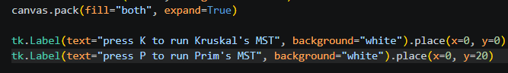
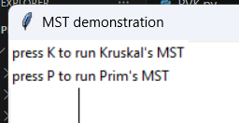
I began by placing a label on the screen that tells the user how to use Kruskal’s. I did not bother with resizing as I was perfectly happy with it staying in the top left corner of the screen. I also decided to do the same for Prim’s now, as I will inevitably need it later anyway.

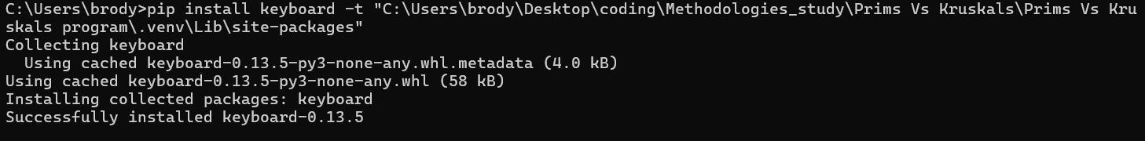
I then installed the keyboard library into the environment and added the import for it. this did include downloading in cmd instead of visual studio code as I could not find how to download packages in visual studio code. Either way, it worked.

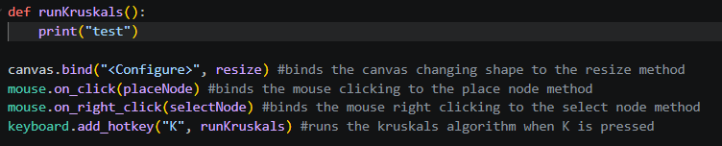
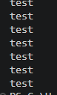
I then set the hotkey to run a Kruskal’s method – finishing off all of the easy setup required for this sprint.

I thought the most appropriate thing to begin with would be the loop of going through every connection.
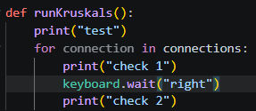
however, I greatly struggled with getting the code to loop through whilst waiting on a keypress. This was my initial code yet pressing the right arrow simply would not cause the second check to be printed no matter what. Even with different keys.
I tried to do some research into keyboard.wait() yet came up empty handed. This left me with two options, create a loop that constantly checks for a keypress or create another hotkey that advances Kruskal’s. I decided on the latter options as it felt much more sustainable and efficient.
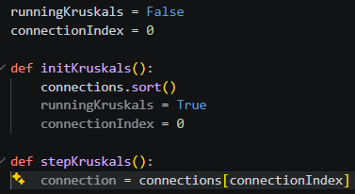

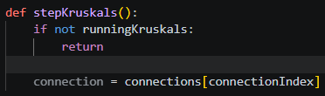
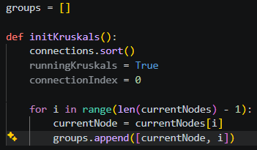
I wasn’t yet sure if I would need all of these variables that I had set but it was most definitely a start. I could then add on to adding the groups to finish the initialisation step alongside a guard clause to ensure that the stepKruskals() method would only run when Kruskal’s is running

I now wanted to start on the actual functionality for the Kruskal algorithm. For each connection this could be split into 4 major sections.
- check the group of the two nodes being connected
- change / don’t change the group of the two nodes being connected
- decide if the connection will be added
- Set the colour of the connection
I would then expect the connection to be removed on the next keyboard press.
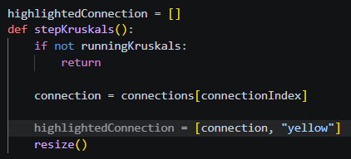
I firstly wanted to start on the changing the colour of the connection, as this would allow me to visualize the problem a lot better. Also checking if the order for the connections is correct.

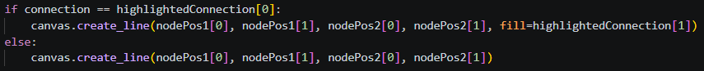
This would be the logic for setting the highlighted connection, I could then add a section in the resize method to change the colour of the connection in the 1st index to the colour in the 2nd index.

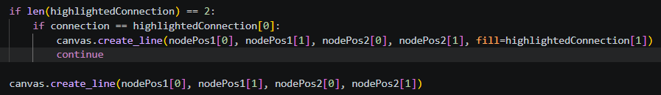
This was my first attempt at setting the colour of the line, this did however cause an error when the highlightedConnection array was not initialised just yet. I added an additional statement for this to only run if the highlightedConnection length is 2

This returned another unrelated error. I entirely forgot what I was sorting the connections array by. I changed the code to accommodate for this.

Now, nothing was being output, I was about to put an if statement into the stepKruskals() method but realised that the highlightedConnection variable was greyed out.
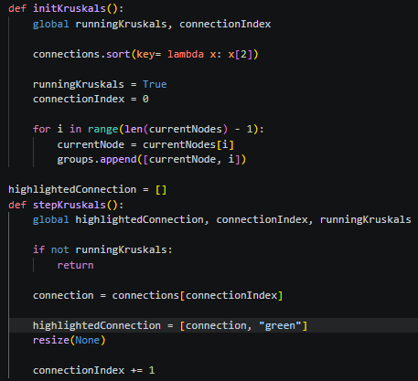
as I had already seen in the project, I knew this would be a simple change of using the global highlightedConnection variable instead. Yet this did not fix the problem, this only made me realise how many variables had to be made global for this setup to work. I added the global tags to every necessary variable only to run into the error that I had forgotten to pass a self parameter into resize() I passed in None and the code would finally highlight one connection.

With the simple change of incrementing by 1 every step. I could now loop through all of the connections on the screen, I additionally changed the colour to be green for now just to make it slightly more visible.
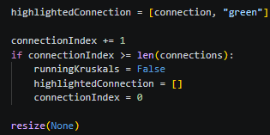
This then of course led to an error that the index could exceed the number of connections. I added some logic to end Kruskal’s if this were to happen.

Because I was setting the connection Index to 0 at the end of Kruskal’s I removed the same logic at the start of each Kruskal’s. I also added a step to the beginning of Kruskal's to ensure that a connection would immediately turn green to indicate that the process has started.
After playing around with this for a bit I finally made the decision to change the width of the highlighted line to 2 as well.
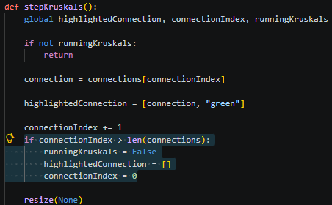
This looked a lot better and also helped me realise that the code for the connection Index was skipping the final connection each time.
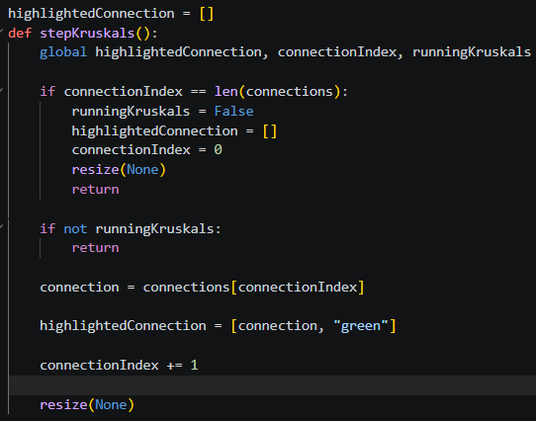
the issue was that the highlighted connection would immediately be reset for the final connection, this would be a simple case of running the code to end Kruskal’s at the start of each method call instead. Alongside adding a return statement to stop any other code from running and a resize call to make sure the final connection didn’t stay highlighted.

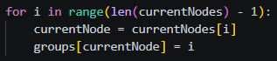
I could now move onto the union find section of this algorithm. I already had groupings that were made when Kruskal’s was initialised, I simply had to add the logic for adding and removing connections. Looking back at my code I didn’t really like the fact that I had used a 2D array to store the groups of each node. I decided that the best option would be to use a dictionary instead so that it would be easier to get the group of a node with only the node.
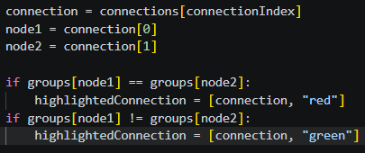
By printing the result of this code with 3 nodes on the screen, I did notice that only 2 of the nodes had groups, this made me realise that I had set the stopping point to be on the final node instead of after it. by removing the -1 in the loop, this would be completely fixed. I then moved onto the basics of the union find, highlighting nodes green if they would not form a cycle and highlighting them red if they would form a cycle.
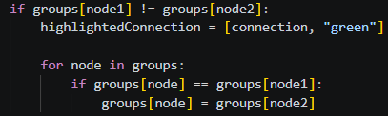
This would highlight connections red if they would form a cycle and green if they would not. I of course had not added the logic just yet to change the groups of each node and that would be the next step. What made this slightly more complicated is that I had to change every single node with the same group, I decided on looping through the groups dictionary and changing any node with the same group.

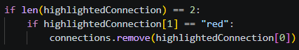
This would work! Highlighting all connections that would form a cycle in red. I next wanted to ensure that these cycles would be removed on the next right arrow press.

This did lead to the connection index looping past the length of connections and crashing so I added an additional line to reduce connection index by 1. This would work and fix the crashing.
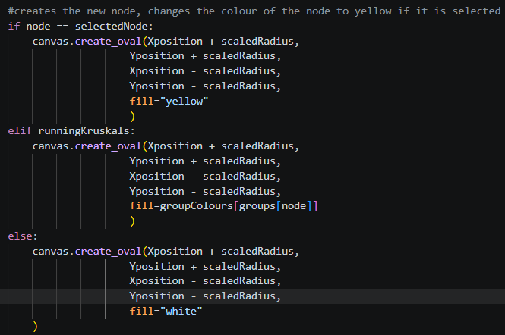
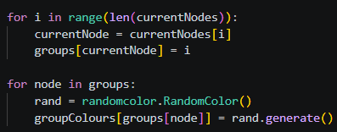
There was another error, however. Not every cycle was being detected and removed. To help me in debugging, I decided to colour every node of a certain group the same colour. To help in getting the random colour, I used the randomColor library and used a second dictionary to assign each group to a colour.

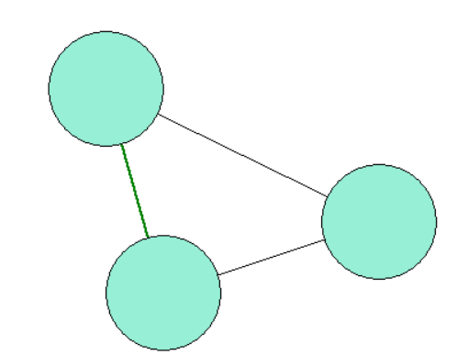
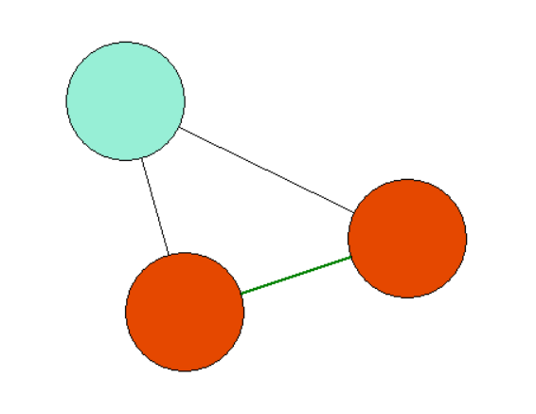
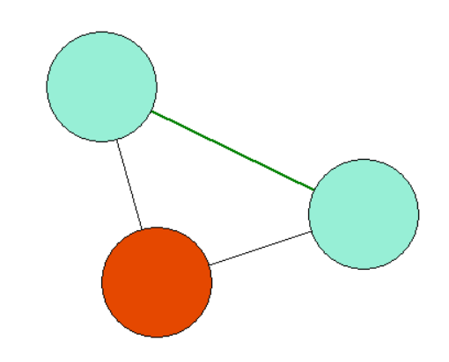
With this in place, it became extremely easy to notice the problem.

You can see here that not every node was being set to the same group as they should have been. This was strange though as it would work sometimes and not work other times. One thought I had was that I was changing the group of the node that was being used to compare to other nodes as I looped through every node, this could cause a problem.
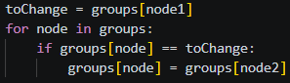
By using a consistent variable to store the group that was being changed, the code would work! Kruskal’s MST could now be run on a graph. I did however want to add one thing before moving on.
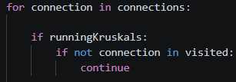
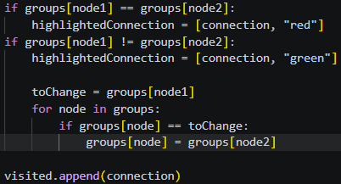
Currently, it is a bit hard to read the process as the connections aren’t slowly added like typical Kruskal’s. they’re instead removed. I wanted to make it so that the connections started with nothing on screen and slowly added new ones on.

I achieved this through using a visited variable, where only visited connections would appear on screen.
I also decided on keeping the randomly coloured groups as they illustrated union find quite beautifully.
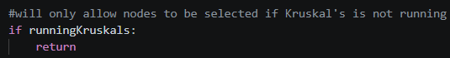
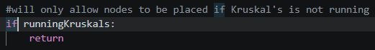
The only part left to implement now would just be to ensure that nodes and connections could not be made when Kruskal’s is running. This was as simple as adding a guard clause to each process.

After commenting my code, everything in my design was finished. I could now move on to testing.
Testing
Pressing k will begin Kruskal’s on the current graph. This should be displayed somewhere on the window.
Pressing K is the only key that will begin Kruskal’s and the label that indicates this does not interact with the nodes at all. I also found that pressing K with no connections will not cause any error.

When Kruskal’s has begun the list of connections will be sorted in ascending distance and an array will store all nodes and their group.
although it did seem like this was working I could be sure by printing the connections array.

where you can see that the distance is sorted in ascending order. I could not find any errors with this.

the right arrow can be pressed to move onto the next connection that is being checked in Kruskal’s. it will be…
the right arrow key is the only key that will advance Kruskal’s when pressed. Unless there is a numpad where the right key on that will also advance Kruskal’s, I do not see this as a bug however.
I found that by pressing as quickly as possible, the code would not break. I also found that by holding down the right arrow key I could quickly advance through Kruskal’s, which I liked quite a lot, as it allows for users to quickly end the algorithm.
Pressing the right arrow key when Kruskal’s is not running does not indicate any errors or strange behaviour. It is simply ignored.

…added if the groups of the two nodes are different / ignored if the groups of the two nodes are the same / if added, the connection will flash green before moving on / if ignored, the connection will flash red before being removed
All of these can be checked by making many different graphs and running the code on them all. Throughout these several tests, I did not find any problems despite how absurd I made the graph look.
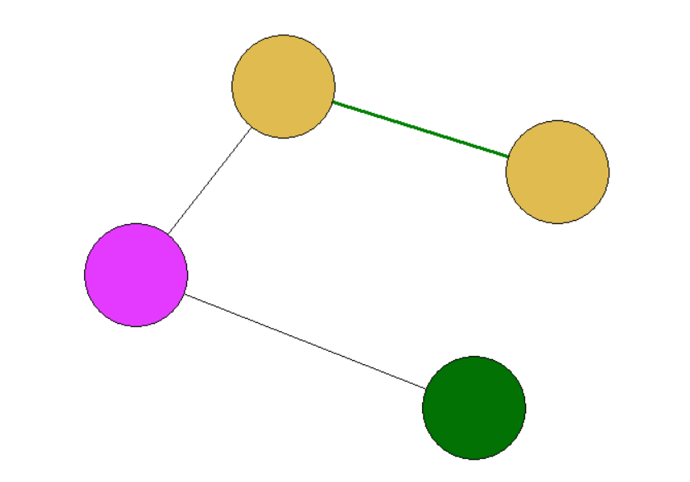
I did find a different error though. By running Kruskal’s a second time, I found that the visited array would never be cleared, meaning that the second time would start with all of the connections appearing on screen that were in the first.

This was a simple fix of setting the visited array to empty when the algorithm finishes. This also meant that I had to add visited as a global variable.

it is not possible to place or select nodes when Kruskal’s is running
thanks to the final guard clause this seems to work as intended. I checked on the first and last connection to be sure and found no error.

I could now move onto sprint 4 – the final sprint.
Sprint 4
This sprint is possibly the most concerning of them all. I have done no research prior to this on implementation of Prim’s in python and it is already quite a difficult algorithm to implement. I hope that the work done in the prior sprint will be able help quite a lot in this one. In terms of time, this sprint took 4 days of work yet because I could not work on the project for one of those days it means that it essentially took 5. I have 5 days to finish this project and half an hour left of my session today.

Research
I firstly began by reinforcing my understanding of Prim’s as I had done for Kruskal’s. the rules for Prim’s are:
- Start by picking a starting node
- From that node, select any connections that will lead to a new node that has not been visited yet
- Choose the shortest connection and add the node to the visited list.
Already I could see a few issues with this. I would need to find some way to allow the user to select a starting node. I will need some way to get all of the connections from all of the visited nodes that don’t lead back to an already visited node.
Yet despite the fact that this may be slightly complex, it was most certainly possible. This was no longer even a matter of knowing the correct code, it was instead the design that I decide to follow and how efficient it accomplishes its task.
The one line of code that I did want to know was one that could remove a subarray if any of its elements matched a query. I did not find any efficient code to do this and thus would have to use iteration.
With the focus on design this sprint, I already decided to move onto it.

Design
- When pressing P, Prim’s algorithm will begin
- Prim’s will not advance until a starting node is selected via right click. This starting node will be added to a visited array to indicate that a node has been selected.
- Pressing the right arrow will advance Prim’s, this will use the same method as the one to advance Kruskal’s via the right arrow. For each step:
  - the algorithm will set an empty smallestConnection variable and begin looping through every connection
  - If the connection includes only one visited node and it is smaller than the already chosen smallestConnection then it will be set to the smallestConnection variable
  - Add the new smallestConnection to the tree
  - The new node connected will be added to the visited array
- Kruskal’s cannot be started during Prim’s and vice versa
- Nodes cannot be placed or selected during Prim’s (except for when selecting the starting node)
A lot of the goal in this design is to copy from the code that I used for Kruskal’s, reusing the code to highlight connections, advance the algorithm and such. The only part of this which I believe might be inefficient in any way would be the process of deciding on the smallest connection to add. I did explicitly make sure it only required one loop to do this however to ensure the most efficiency possible.

Implementation
I first wanted to start by implementing all of the necessary hotkeys. This would involve me adding a new hotkey for Prim’s and changing the method for the right arrow hotkey.
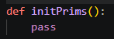
Simply adding the hotkey to begin Prim’s was fairly simple. Being extremely similar to what I did for Kruskal’s.

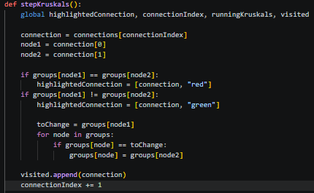
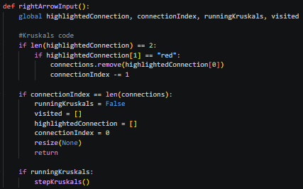
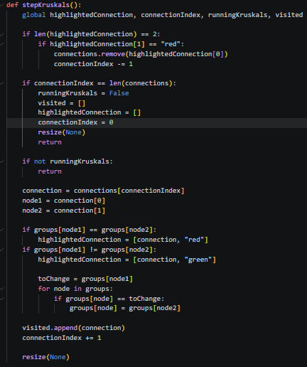
The right arrow key was more complex, as it did something different depending on if Kruksal’s or Prim’s was running. I decided to make the right arrow key run its own method, inside that method it will run all of the code before the second guard clause in the original code and then run Kruskal’s if runningKruskals is True.
This did not seem to break the algorithm at all and allowed me to implement the stepping of Prim’s forward on right arrow key press.
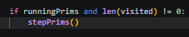
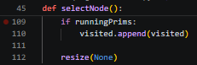
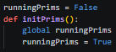
I believed that the most adequate place to begin would be the initialisation of Prim’s, which would include selecting a starting node. The function for this itself was actually extremely simple as most of the initialisation was already implemented in the selectNode method.

This would force the user into selecting a node before they can begin the process of stepping through Prim’s.
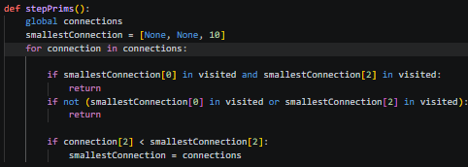
This was my first attempt at the StepPrims() method.
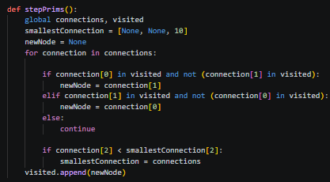
But I could see this code had far too many errors to count before it was even ran. It also did not store the new node being added in any way.
This new method felt a lot more foolproof as it stored the node as part of the process. I still did not like this code too much though, as it used the visited array for nodes. It would be much more efficient to use it for the connections, as the resize method is already designed to only show connections that are in the visited array when Kruskal’s is running. I created a separate array for visited nodes and extended the logic to show visited connections to Prim’s also.
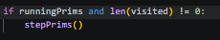
This already seemed as if it should be working so I ran the code. I could press P and select a node, causing all connections to disappear. Yet pressing the right arrow would not advance anything forwards. I added a print statement to the stepPrims() method and saw it was not running at all. By looking through the code, I looked at all if statements that may block it from running and found the culprit.

I was still using the old visited array when checking to see if any nodes had been visited yet. This still did not cause anything to happen on screen. I decided to check the smallestConnection and found that it was not changing from its base value at all, only to realise it was another error with not changing the array for visited to visitedNodes instead.
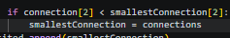
This would cause another error, instead crashing the program and stating that smallestConnection was a 2D array. The only point that smallestConnection is set to a value is when it is set to the connection after all checks are valid. I checked that line and surely found an error.

I had said connections instead of connection, causing an error.
By fixing this the code still would not work, yet in my experimentation I clicked on the window again and saw that the connections would suddenly reappear. This made me realize that the issue must have been with the resize method.
I added on that method to the end of each step and began to see some actual progress in my code. The Prim’s algorithm would grow and work to some extent. It just did not always lead to a correct tree.
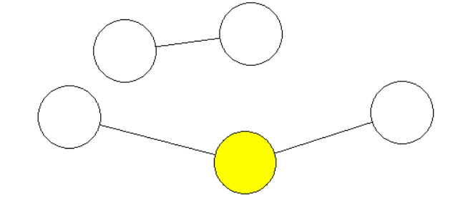
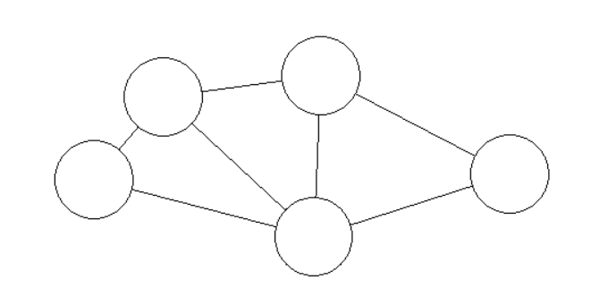
It appeared to be missing some connections. I decided to check what connection was being added on each step.
What this revealed was two things. Firstly, the node on the first step was different to the nodes inside of the connection, meaning that the newNode was being chosen incorrectly. Secondly, the same connection was being added to the tree twice.

Looking at my code, I could see a potential error, the code to set the new node was running before setting the smallest connection. Meaning that the new node could be different to the one in the smallest connection. I changed my code to fix this.

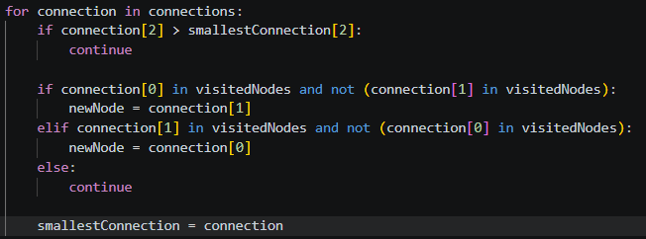

And with that change, the code worked. Prim’s could be ran on the tree. This was most definitely a shock as I was only 10 minutes into my second day of programming for this cycle. It was not entirely finished just yet however, I still had a few things left to do.
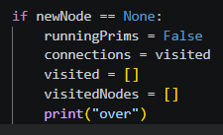
I firstly ensured that the algorithm could finish, this was as simple as ending the algorithm when newNode does not get set to a value across the loop.
This did however cause a crash, it was swiftly fixed by adding a return statement to ensure that the code would not run any additional logic for Prim’s once it’s already over.

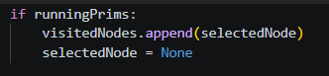
Something that had really been annoying me throughout the process of developing this was that the selected starting node would stay yellow throughout the entire process. I added a small line to when it is selected during Prim’s that would immediately clear the contents of selected Node. Stopping this from happening.
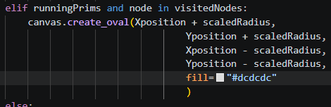
In place of this, I added logic to the nodes that they would be greyed out if they had been visited.
At first I used “light grey” as the colour yet found it far too dark. I chose this hex colour I found online that was much lighter and vibrant for the program.
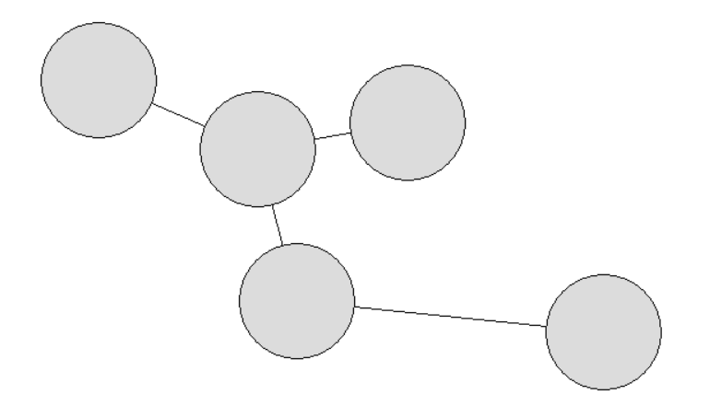
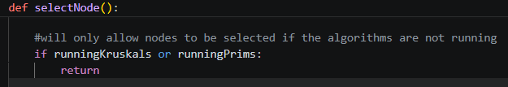
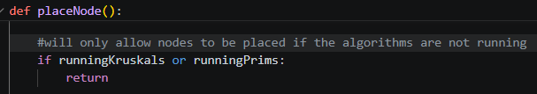
The final sections on my design are just to avoid bugs. I need to stop Kruskal’s from being able to be ran in Prim’s and vice versa. Alongside stopping nodes being selected and placed as Prim’s is running. The latter would be as simple as just extending the lines for Kruskal’s
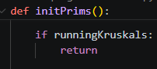
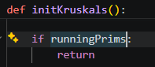
Then the former would be as simple as adding a guard clause to each initialisation method (alongside making the variables required for each clause global)

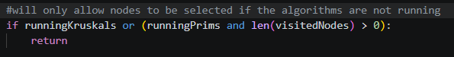
This new code would cause Prim’s to stop working. A node could not be selected when Prim’s is running – not allowing the initial node to be selected.

I changed the code to only not allow a second node to be selected.
Now before I end the programming for this sprint, I did want to do some final cleanup for the program and add a new feature I’ve had in mind.
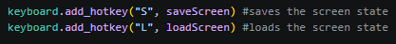
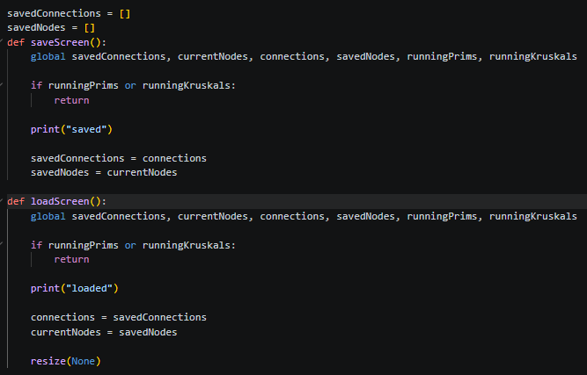
One issue I’ve seen when testing the program is that it is nearly impossible to actually compare Prim’s and Kruskal’s when you can’t run them on the same tree. That is why I’m planning to add a save and load feature, where you can save the current state of a tree and then load it back on to the screen.

This is the code that I managed to scrap together. It seemed as if it should have worked just fine, except for the fact that it was doing nothing. The print statements were still running though. I checked the values of connections and savedConnections when loading and found them to be the exact same. That’s when I realised, I had set the saved values to the actual values by reference, meaning they would just be the exact same.
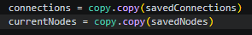
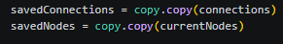
I had only ran into this issue a handful of times in the past and thus had to research how to handle this. I found a library called “copy” that allowed me to create copies of variables to set by value.
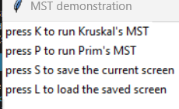
This would lead to the code working as expected. I also made sure to add labels that tell the user this function exists.
I also decided on adding a few extra guiding labels to help the user. I added a label that would only appear when Prim’s or Kruskal’s was running and tell the user to use right arrow to advance forwards.
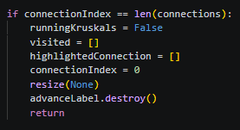
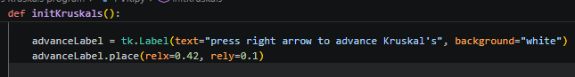
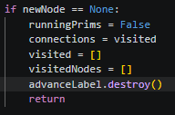

but this did not compliment itself kindly to resizing, I decided to place it under all of the other labels instead but colour it red to stand out.
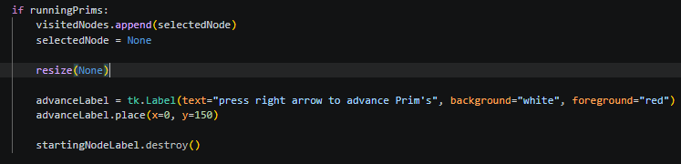
I also added a label for Prim’s when selecting a starting node. This actually caused me to change when the label would show up telling the user to advance Prim’s, I instead made it appear after the user has selected a node.
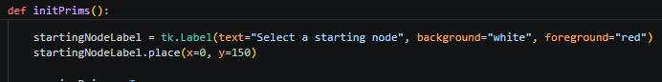
And with this, all of the code in the project was complete. I commented all of my code and moved on to testing.

Testing
When pressing P, Prim’s algorithm will begin
This works as intended. Pressing P will start Prim’s and no other key is able to do so.

Prim’s will not advance until a starting node is selected via right click. This starting node will be added to a visited array to indicate that a node has been selected.
This works as intended. It is not possible to place or connect nodes during this time or do much of anything except select a starting node. I was interested as to what would happen if there were no nodes on the screen however.
It would make the user select a node when there was none. To fix this I added a check to the initialisation of Prim’s that would only start Prim’s if there was at least one connection.

Pressing the right arrow will advance Prim’s, this will use the same method as the one to advance Kruskal’s via the right arrow. For each step:
Pressing the right arrow will advance Prim’s, no other key is able to do so (except for the right arrow on the numpad).

the algorithm will set an empty smallestConnection variable and begin looping through every connection. If the connection includes only one visited node and it is smaller than the already chosen smallestConnection then it will be set to the smallestConnection variable. Add the new smallestConnection to the tree. The new node connected will be added to the visited array
the process of Prim’s appeared to be working just fine but after a few attempts of using it, I found 2 main errors that were extremely prevalent.
Firstly, occasionally the algorithm would end and yet all of the nodes on the screen were still grey until the screen is resized. This was as simple as adding resize(None) to when the algorithm ends.
The second issue would lead to a crash, where the advanceLabel was apparently a none type at the point of destroying it. I immediately assumed that this was an issue with variable globalisation, I made the advance label global when I set It and my code worked. However, the other label would now appear, I assumed it was a similar issue and thankfully it was.

Kruskal’s cannot be started during Prim’s and vice versa
I tried starting both during the other at every step of the algorithm and could find any point where one could be started in the other. I will consider this feature working

Nodes cannot be placed or selected during Prim’s (except for when selecting the starting node)
I tried placing and selecting at every step of Prim’s and found no point where a node could be placed or selected (except for selecting the starting node)

The screen can be saved and loaded
I could not find any error with this feature. The only semi-bug is that loading without anything saved will just clear the screen but I actually didn’t particularly mind it.
This did give me inspiration for another feature to add however, I would need a clear screen button so that I don’t have to repeatedly close the app to get all nodes off of the screen.
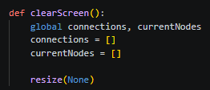

I now had a fully functioning program and could move on to Evaluation.

Evaluation
Despite my best efforts, this program has yet again appeared to have put me another 10,000 words down and I ended up writing nearly 500 lines of code throughout the process. This took a lot of effort but I am so incredibly proud of the end result, so proud in fact that I am planning to compile the program and give it to my further maths teacher to teach the next year of further mathematicians.
I truly feel as if I had a very minimal amount of errors in this process. The worst that I have done is not research everything necessary and end up having to research in implementation, yet that was only for small amounts of code. This is the first development process in this study thus far that has felt organised and on track for the entire time. I do believe that a part of that is because of the flexibility of Agile but I also do just really enjoy Agile’s process as a whole with such a focus on coding.
Now to talk about what I reinforced in my mind about Agile as a result of this program.
- Flexibility. If I truly wanted to, I could have done an entirely different algorithm in the final sprint instead of Prim’s and I could add and remove features exactly as I wished. Agile truly allows for flexibility when creating a solution which I greatly commend it for. This also allowed for me to still complete the project despite the fact that I had a camping trip halfway through.
- Much less focus on documentation. The majority of the pages in this document are just me programming, a page of research or design would take a maximum of 1 page as I was only taking a short break before going straight back into the coding
- Iterative focus on versions. With each sprint a new version would be created that in a situation with a client could be reviewed alongside them and improved on. The iterative nature of Agile is also very easy to notice, every sprint will follow the same exact structure to keep things fairly organised.
- Deadlines. Although this project did not struggle that much with meeting self-imposed deadlines, I was still extremely close at points to breaking them. The largest issue with time management is that you don’t know what will happen in a sprint until you reach it, so it’s extremely difficult to estimate how long it will take.
- Communication. As a result of poor deadlines and hardly any documentation I could not see any way that I would be able to work on this project with another person. This would be remedied slightly if I were to add in evaluation stages to each sprint, but even so, communication is very difficult.

Despite all this, I would say that Agile is a methodology I enjoy quite a lot, I would put it on par with spiral in terms of how enjoyable it was.
For my next project I was slightly lost on what to do, it was the only one that I did not have a plan for just yet. I was originally planning on using it to learn website design, but that does not interest me very much. That’s why I’m planning to take part in Brackeys game jam on August 23rd to August 30th.
This will be very different from my other projects and will likely not include much documentation of the programming process instead just having diary entries of each day. If anyone has read all of this somehow, thank you very much and see you in the next project.

